**Statement of Objective:** Design of automatic door bell ringer

**Software Used :** Multisim 11.0 .

**COMPONENTS REQUIRED:**

* Capacitors (1000uF, 1 uF)
* Resistors (1k, 10k 100k) and Variable Resistor (10k)
* Buzzer or Speaker
* Push button Switch
* Battery- 5- 9v
* LED (Optional)

**Theory:** Doorbell is a very common and useful device used in every household. It can be quite useful in our post-Covid-19 world as it minimises the spread of virus through doorbells. In this circuit we are using two 555 timer ICs, one to control the “ring duration” (how long it should ring on single button press), and other is to control the oscillation frequency of sound produced by bell. First IC will work in **Monostable mode** and second IC will work in **Astable mode**.

To control the “ring duration”, we connected the OUTPUT pin (3) of the first 555 Timer IC to the Reset pin (4) of the second 555 Timer IC. Means as long as the output pin of First IC will be high, Second 555 Timer IC will oscillate. Fourth Pin of the 555 Timer IC is the Reset pin, IC would only work if this pin is HIGH means connected to the positive voltage, if this pin is connected to the Ground, the IC will not work and changing/discharging of the capacitor will stops.

**CIRCUIT DIAGRAM AND EXPLANATION:**

The circuit consists of two 555 timer ICs arranged as shown in the circuit diagram. The first timer IC is connected in astable mode to produce pulse of frequency 1Hz. The 4th and 8th pins are shorted and connected to the resistor of 2.2K whose other end is connected to the pin of the timer IC. Sixth and seventh pins are connected to the variable resistor. Sixth and second pins are shorted and connected to the ground of 9v through a capacitor of 47uf. Fifth pin is connected to the ground through a capacitor of 0.01uf. First pin of the IC is connected to the ground.

The output pin of the first IC is connected to the control pin i.e. Fifth pin of the second IC. The second IC is also operated in astable mode again. 4th and 8th pins are shorted and connected to resistor of 2.2 k ohms whose other end is connected to the seventh pin of the IC. A variable resistor 100K is connected between sixth and seventh pins of the IC. Sixth pin and second pin are shorted and connected to the ground through a capacitor of 0.1uf. First pin is directly connected to the   ground of 9v.Output pin of the IC is connected to the speaker through a capacitor of 1uf.

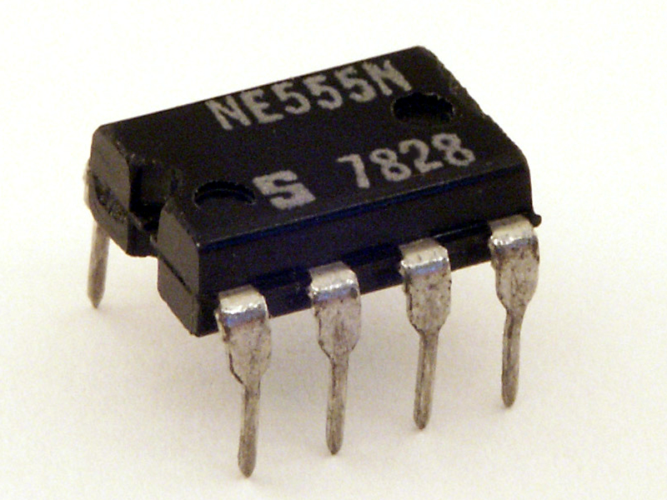

The **555 Timer** IC got its name from the three 5KΩ5KΩ resistors that are used in its voltage divider network. This IC is useful for generating accurate time delays and oscillations.

Introduced in 1971 by the American company Signetics, the 555 is still in widespread use due to its low price, ease of use and stability. It is made by many companies in the original bipolar and low-power CMOS types. According to an estimate, a billion units were manufactured back in the year 2003 alone.

Depending on the manufacturer, the standard 555 timer package includes 25 transistors, 2 diodes and 15 resistors on a silicon chip installed in an 8-pin mini dual-in-line package (DIP-8). Variants consist of combining multiple chips on one board. However, 555 is still the most popular. Let us look at the pin diagram to have an idea about the timer IC before we talk about 555 timer working.

#### ****How Automatic Door Bell Ringer Circuit works?****

* Initially power the circuit.
* The sound can be heard from the speaker.
* When the power is on the circuit is operated in the astable mode.
* As the voltage is applied to the timer, the capacitor starts charging through the resistors R1 and R2.
* When it reaches 2/3 of VCC, it is detected by the sixth pin and seventh pin is connected to the ground.
* Thus capacitor starts discharging, through the RV1 resistor.
* When voltage of 1/3 VCC is detected it again starts charging, thus this process continuously produces the pulse of frequency 1Hz.
* This is applied to the second  timer through its control pin.
* Thus the frequency of the second timer is modulated and is applied to the speaker through a capacitor.
* The external RC circuit decides the time delay with which the waveform should be produced.
* Hence one can hear the sound produced.

#### ****Applications:****

* The circuit can be used as a door bell by connecting the supply to a switch.
* With some modifications it can be used to produce different sounds.

#### ****Limitations:****

* As the applied voltage is 9V, it cannot produce more sound.

**ADVANTAGES:**

* Automatic door bell ringer is low-cost, and a simple circuit.
* It is very reliable and effective circuit for a doorbell works without touching.
* It can be quite useful in our post-Covid-19 world as it minimises the spread of virus through doorbells.

**Results and Analysis:**

#### Possible sources of error:

1. Human error
2. Observational error

#### Precautions:

1. Place the component very carefully on the Multisim software.
2. Be careful in taking scaling in several plotters.